|  |  |
| --- | --- |
| Assignment 3  ITRI 615 | Enrico Dreyer  31210783 |

Table of Contents

Introduction 2

Physical security controls 2

Gates, walls, and fencing 2

Guards 3

Dogs 3

Badges and ID Cards 4

Keys and locks 4

Mantraps 5

Electronic Monitoring 5

Alarm Systems 6

Computer Rooms and Wiring 7

Interior Walls and Doors 7

Conclusion 8

References 8

# Introduction

This paper will discuss the physical controls according to Michael E. Whitman (2017), that the North-West University follows to safeguard the computer facilities on the top floor of building 9A. This paper will evaluate the controls that are in place, possible improvements, highlighting their relevance, and the role they play in improving the security as well as consider the controls that are not in place and make recommendations on improvement if necessary.

# Physical security controls

According to Michael E. Whitman (2017) there are several physical security controls that need to be considered when implementing physical security outside and inside of a facility, like the computer rooms at the North-West University. These physical security controls include:

* Gates, walls, and fencing
* Guards
* Dogs
* Badges and ID cards
* Keys and locks
* Mantraps
* Electronic monitoring
* Alarm systems
* Computer rooms and wiring closets
* Interior walls and doors

Each of these factors will be discussed in detail in the next section of the paper.

# Gates, walls, and fencing

This is one of the most reliable physical security measures and is one of the first things to implement when starting a computer room or server. This can vary from facility to facility and include the walking areas and parking, this creates a barrier from any harm of the outside. This physical security measure requires expert planning so that it can ensure that the security goal is met.

At the North-West University, they have gates, walls, and fencing stretching around the University. This ensures privacy to the University from the outside world. This physical security measure is highly relevant and is a big help to securing the computer facility. Improvements include having higher fences or fences that are not see-through, so that people from the outside cannot look in.

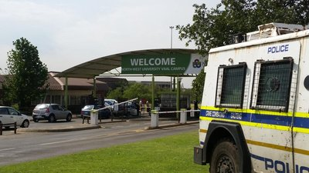

# Guards

Because walls and fences are static, they cannot respond to when something is happening at that moment that can cause harm to the facility, unless they have sensors to open when someone has a key. This is where guards can act upon a situation. Not only is this physical security measure expensive, but it is in the human nature to get bored or distracted, this can cause things to “slip” through that can harm the facility.

At the North-West University, they have guards at the gates, and have guards late at night at the computer facilities to lock up after everyone left. This is a relevant physical security as they give only people that are allowed on campus access to the university as well as check the cars for potential threats. An improvement will be to have guards at the computer facilities at all times and not just at night to lock up. This will decrease the chances of something happening to the facility.

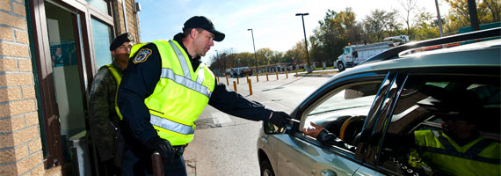

# Dogs

Dogs are mainly for protecting valuable resources. Dogs are a great measure for their use of smell and hearing intrusions that people cannot detect. They can also be used to place in harm’s way instead of a person.

The North-West University does not have guard dogs and would be a great improvement to security, but is not that necessary as guards have proven to be enough. Instead of having just a human guard protecting the facility, the university can have a guard dog as well.

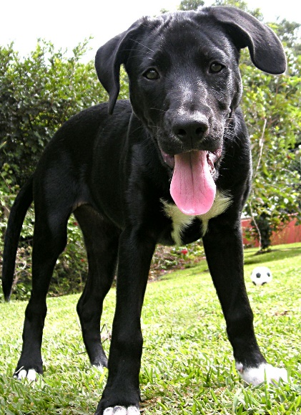

# Badges and ID Cards

An ID card is usually hidden from sight, where a badge is usually worn and visible. This card can be used to identify a person by looking at the photo on the card or badge. They can also be programmed to give a person access to only specific buildings or places. This measure is not perfect, as cards can get stolen, duplicated, or modified to give a person access to places that they are not supposed to have access to.

People can also give other people access to places by the use of tailgating. This is a big security concern at the North-West university, as students give other students access to the computer facilities. An improvement will be to make every door so small that only one individual can enter at a time.

This security measure is very relevant to the University as it controls many users. This can help to track on what person has accessed a certain area last.

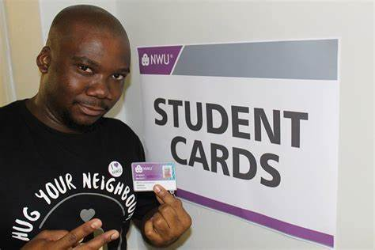

# Keys and locks

This physical security measure can include either a mechanical, or electronical lock. A mechanical lock for example is a door handle with a keypad on it, where a person needs to know the passcode to have access to the area. An electronical lock can receive many was of input as keys, for example an ID card or radio signals.

At North-West University they have these locks on most of their doors. This is a great way of giving access to people to specific rooms inside the facility. There are also electronical locks on the turnstiles when accessing the computer facilities at building 9A. An improvement will be to have both mechanical and electronical locks on each door, so a lecturer has to use their card and a pin to access the specific lab.

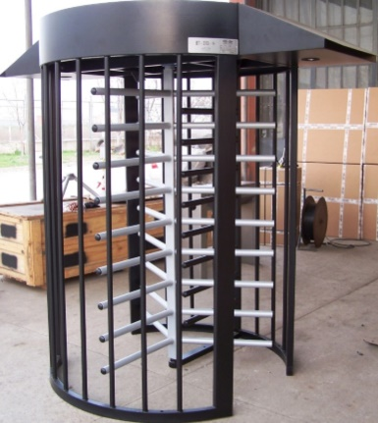

# Mantraps

This physical security measure is used in extremely high-security areas. For entering or exiting an area a person has to use a form of biometric or electronic key.

The North-West University does not use any mantraps. This would be a great improvement then accessing the facility. This would be relevant if they are installing more expensive computers or hosting a new server room that they really want to protect.

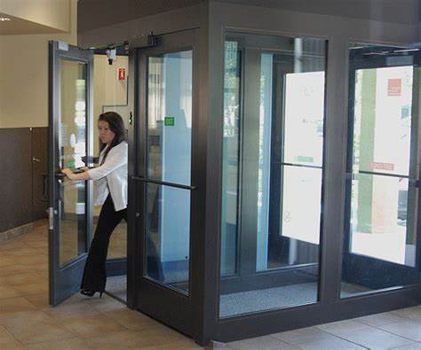

# Electronic Monitoring

This physical security measure includes closed-circuit television. This is useful for having and are an improvement to having guards and guard dogs, in the sense that CCT’s cannot miss something and can also be used to go back to a specific time. The drawback being that they are passive and cannot stop someone from breaking in, or preventing access to an area.

The North-West University has CCT systems in place to record what is happening in the classrooms and facility. This is very relevant for going back to a specific time to when something has gone missing or gets stolen. An Improvement will be to have a picture taken whenever someone uses the doors, this will keep track on everyone that is accessing the facility and prevent cards from being stolen and used.

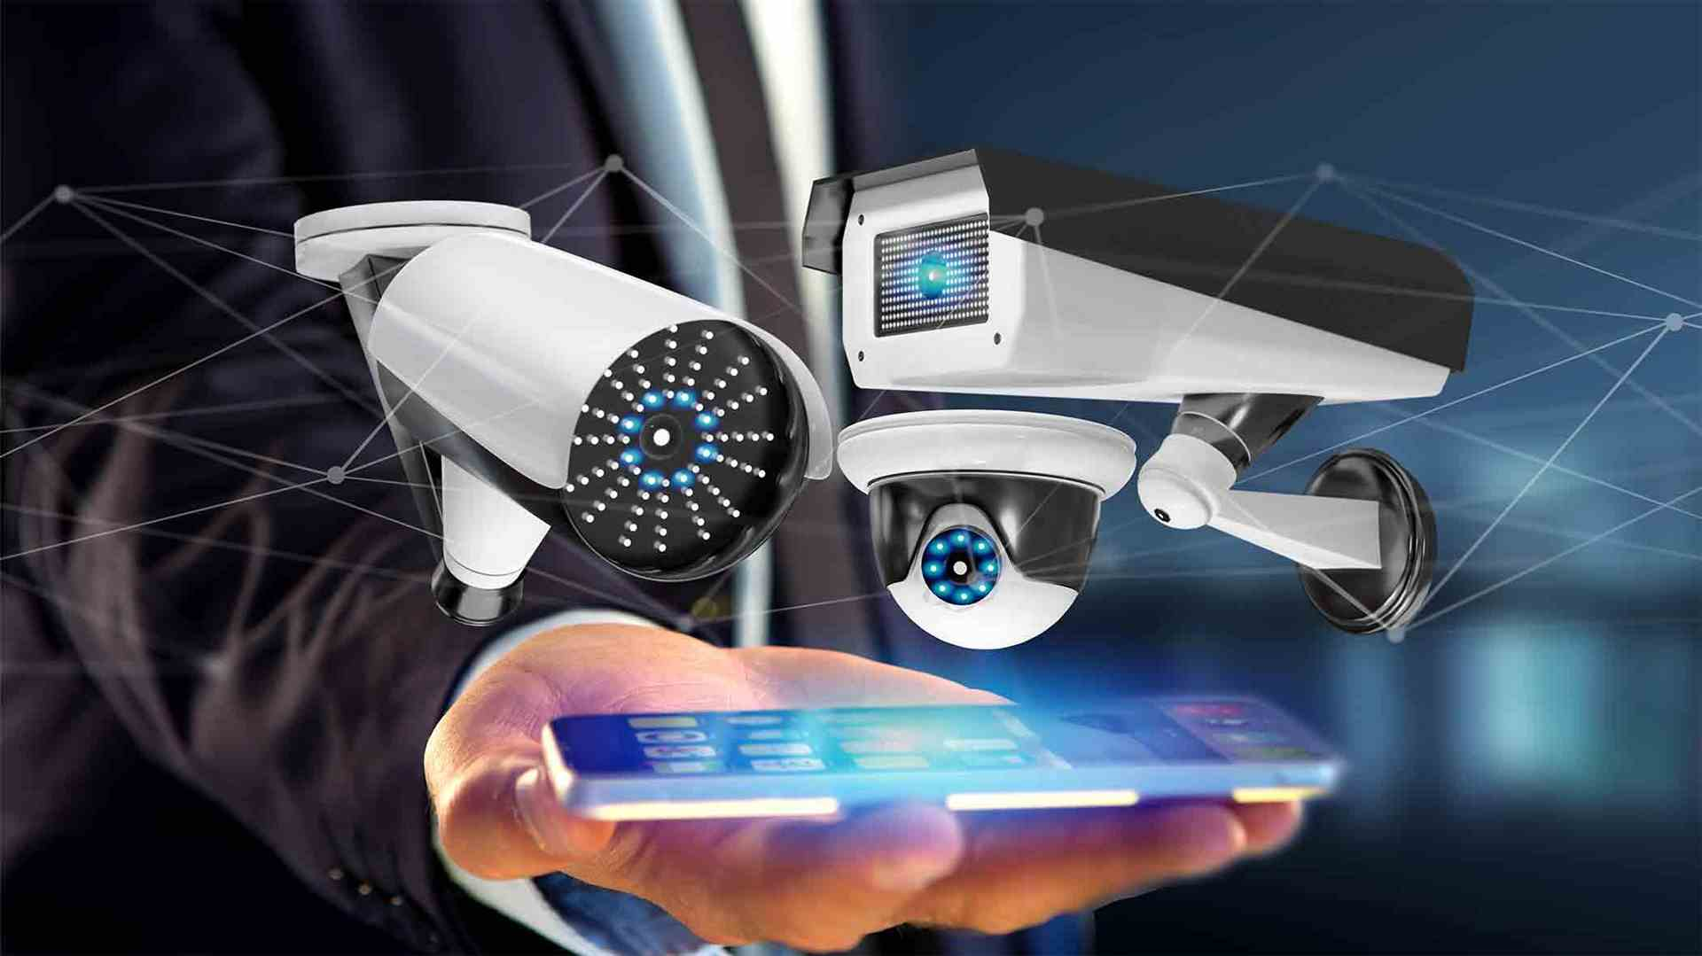

# Alarm Systems

This is used to notify systems or people that a predetermined activity or event has occurred. This can be set of by either a break-in, fire, flood, or a power loss. The most common type is a burglar alarm that detect an intrusion to an unauthorised area that alert the local security department. This is set of by motion sensors inside of the facility.

The North-West University has an alarm in building 9A, that is set on at night when the guard leaves. This alerts the other guards to then something has happened. There is also a fire alarm and sets of a water system to set out the fire, as well as extinguishers at the doors for the guards to use. An improvement would be a heat measure to detect if a person is sick, especially with covid to keep people safe. This is very important to keep the computers safe and prevent something from getting stolen.

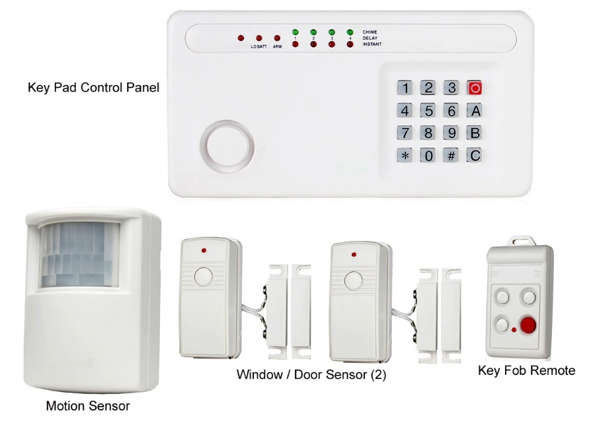

# Computer Rooms and Wiring

This is important to ensure availability, confidentiality and integrity of data and information. This is a physical security measure of giving the right people access to use the computer systems. This is when for example you have cleaners have access to the facility, then they use that access for espionage and gain access to sensitive data.

The North-West University has a lot of students that use their computers and have access to the network, thus their infrastructure is very strong in that regards. An improvement will be to have multiple cleaners at once, thus decreasing the chances of one sneaking off to gather sensitive information or having the looking over someone’s shoulder.



# Interior Walls and Doors

A facility usually consists of two types of walls: firewall and standard interior. A firewall is a wall that protects the different rooms in a facility and minimising the damage in the case of a fire. A standard interior wall is just the separation of one room to another and have the potential of letting a person climb from one room to the next by the use of vents or breaking the roof.

A physical firewall is important to protect and surround rooms that have a lot of valuable devices or important information. North-West University does have thick walls surrounding the computer facilities so that a person cannot break through the walls to get access to the computer facility. Building 9A’s computer facility is also on the first floor, making it exceptionally harder to get access to.

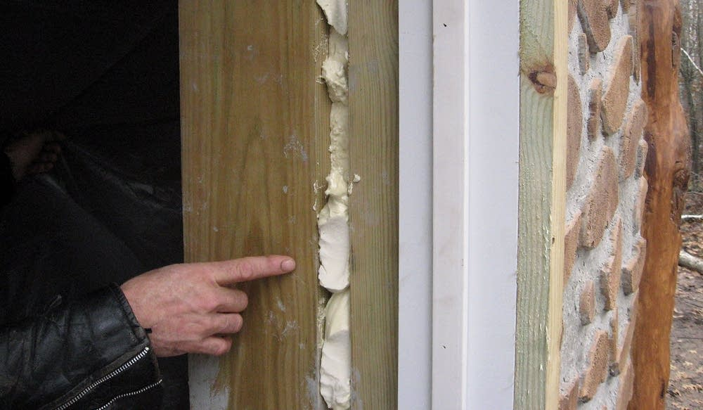

# Conclusion

This paper discussed the physical access controls set in place by North-West University. It also pointed out which of the physical access measures are important. The North-West University is a big organization and has considered all of the measures and there is a reason why some of them have not been implemented, most likely because of the cost-risk ratio, for it will cost more to protect than what it is worth.

# References

Michael E. Whitman, H. J. M. (2017). *Principles of Information Security* (6, Ed.). Cengage Learning.